**Short answer practice questions**

1. Label the indicated parts on the diagram of the alimentary canal shown. (3 marks)

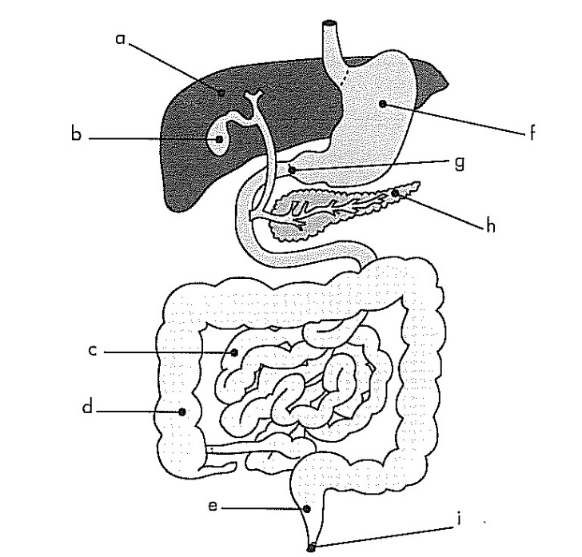

**a:** ___________________________

**b:** ___________________________

**e:** ___________________________

**f:** ___________________________

**g:** ___________________________

**h:** ___________________________

1. State one complication that could occur if “g” did not work properly? (1 mark)

__________________________________________________________________________________________________________________________________________________________________

1. Explain the role of “b”. In your explanation state why it is vital to the functioning of the digestive system. (3 marks)

____________________________________________________________________________________________________________________________________________________________________________________________________________________________________________________________________________________________________________________________________

1. Fred just ate a dry piece of toast and wondered what happened to it once he put it into his mouth. Write an explanation for Fred on how the piece of toast is digested before it can be absorbed into his blood stream. Include all types of digestion. (5 marks)

________________________________________________________________________________________________________________________________________________________________________________________________________________________________________________________________________________________________________________________________________________________________________________________________________________________________________________________________________________________________________________________________________________________________________________________________________________________________________________________________________

1. Explain the difference in the position of the bones in the axial skeleton and the bone sin the appendicular skeleton. (1 mark)

_________________________________________________________________________________

1. When a long bone is broken this often results in bleeding from the bone. Why does the epiphysis not bleed as much as the diaphysis if it is broken? (2 marks)

___________________________________________________________________________________________________________________________________________________________________________________________________________________________________________________

**A**

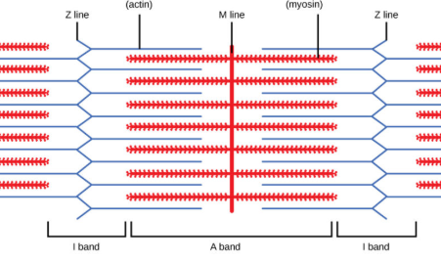

**B**

1. The diagram represents the sliding filament model of muscle contraction. A sarcomere in a skeletal muscle is shown in the relaxed position.
2. Identify the proteins labeled as A and B in the diagram.  (2 marks)

A _____________________________

B _____________________________

1. In the box below, accurately draw the same sarcomere as it would appear when the muscle is contracted. (2 marks)
2. Explain what will have to happen for the sarcomere to return back to normal. (2 marks)

________________________________________________________________________________________________________________________________________________

1. Why do ligaments take longer to heal than muscles? (2 marks)

___________________________________________________________________________________________________________________________________________________________________________________________________________________________________________________

1. [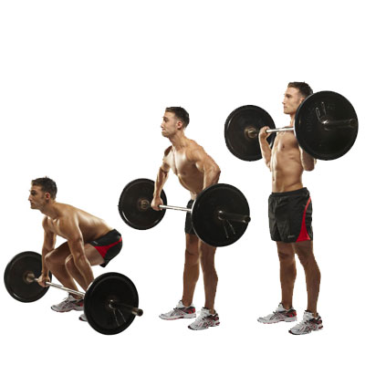](http://www.google.com.au/url?sa=i&rct=j&q=&esrc=s&frm=1&source=images&cd=&cad=rja&uact=8&ved=0ahUKEwiRmNmhvq7NAhXBkpQKHdMlB1EQjRwIBw&url=http://www.top.me/fitness/take-your-fitness-to-the-next-level-with-complex-training-1100.html&bvm=bv.124817099,d.dGo&psig=AFQjCNHMV2agSm44aHcdA0Z3ZtpZXuj0jA&ust=1466233100823096)The “clean and jerk” is an Olympic sport for the powerful. The use of the legs and arms are shown in the diagram opposite.

Using the diagram to help you, discuss how the major muscles, bones and joints in the leg move to achieve the straight leg position. (4 marks)

___________________________________________________________________________________________________________________________________________________________________________________________________________________________________________________

___________________________________________________________________________________________________________________________________________________________________________________________________________________________________________________

1. The liver plays a vital role in the recycling of nutrients in the human body. One of its roles is to break down old red blood cells to retrieve the haemoglobin, in doing this it makes waste products that need to be removed, this process is called deamination. Describe the process of deamination. (3 marks)

____________________________________________________________________________________________________________________________________________________________________________________________________________________________________________________________________________________________________________________________________

1. How does the body deal with the waste product produced by deamination? (2 marks)

___________________________________________________________________________________________________________________________________________________________________________________________________________________________________________________

1. *Your response to this question can be written in paragraph form, tables or can refer to labelled diagrams in support.*

The nephron is the primary structure concerned with the formation of urine. It is composed of a number of parts, including the:

* 1. Glomerulus
  2. Proximal convoluted tubule
  3. Distal convoluted tubule

Discuss how each of the structures are suits to their functions function. (6 marks)